Title of the Article Using Title Case

First name(s) Last name(s) • First name(s) Last name(s)

Abstract
Lorem ipsum dolor sit amet, consectetur adipiscing elit. Nulla fermentum scelerisque pulvinar. Sed cursus euismod ante id cursus. Morbi ac dui in sapien placerat iaculis ac a arcu. Vestibulum rhoncus dapibus hendrerit. Morbi facilisis ut dolor non viverra. Donec tincidunt felis sed varius ultrices. Nullam vel enim convallis, pellentesque nisi venenatis, accumsan massa. Cras imperdiet odio ac rhoncus aliquam. Vivamus consequat lorem non tortor consectetur lacinia. Donec sit amet dui porttitor, congue mi id, feugiat dui. Pellentesque tortor nunc, imperdiet eget tempor sit amet, pharetra eget eros. Nulla in leo elementum, venenatis augue nec, tincidunt orci. Cras quam eros, aliquam vitae neque vitae, posuere auctor tortor. Duis id tortor mi. Proin luctus purus id venenatis placerat. Integer nec magna quis neque fermentum convallis vel et nunc.

Keywords
Tincidunt, scelerisque, porttitor, feugiat, culture, tincidunt

Introduction
Lorem ipsum dolor sit amet, consectetur adipiscing elit. Nulla fermentum scelerisque pulvinar. Sed cursus euismod ante id cursus. Morbi ac dui in sapien placerat iaculis ac a arcu. Vestibulum rhoncus dapibus hendrerit. Nullam vel enim convallis, pellentesque nisi venenatis, accumsan massa (EuroINCLUS, 2024). Cras imperdiet odio ac rhoncus aliquam (European Commission, 2024). Vivamus consequat lorem non tortor consectetur lacinia. Donec sit amet dui porttitor, congue mi id, feugiat dui (Central Electoral Commission, 2024).

Vestibulum turpis dolor
Curabitur imperdiet nulla augue, eget porta mi varius vitae. Praesent commodo hendrerit quam, et varius ligula porttitor vel. Suspendisse consequat semper lorem, non pellentesque quam efficitur in. Vivamus aliquam sed lectus vitae euismod. Ut sollicitudin libero non nibh porttitor gravida (Brie and Horga, 2009: 58). Mauris vulputate quis neque in eleifend. Aenean risus ante, mollis eu molestie scelerisque, tristique vel justo. Donec ultricies dolor ut risus tempus condimentum. Quisque tempus sagittis mi, eget porta sem pellentesque vel (Brie and Blaga, 2015: 255-273).
Figure 1. Which statement do you agree with? (ethnic background) (2024) (%)
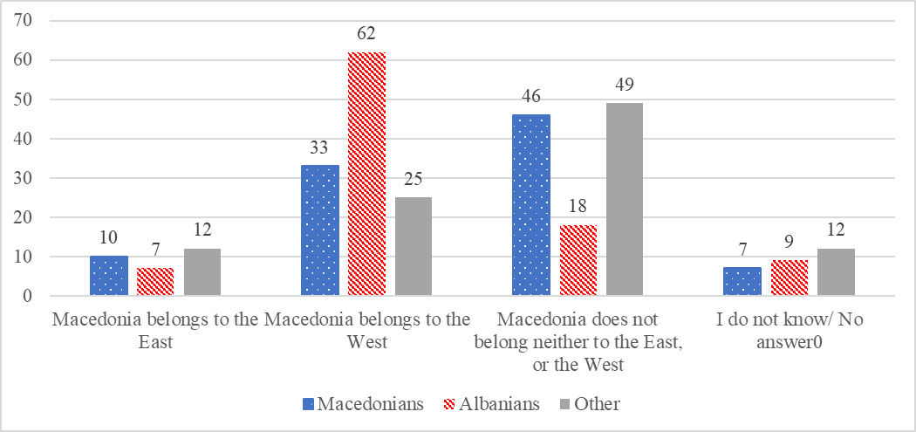
Source: author’s own preparations based on data collected from Velinovska and Sofeska, 2025: 17

Ut ut felis sit amet enim cursus tristique convallis ut orci. Etiam convallis, mauris non tempus dapibus, lacus lorem accumsan felis, vitae lacinia elit dui eu dolor. Mauris tincidunt tempus velit sit amet ornare. Quisque ac egestas quam, in egestas nibh. Praesent efficitur sem ut augue tincidunt pretium. Duis justo lacus, venenatis vel elit vitae, tempus fermentum sem. Donec venenatis nec dolor pretium consectetur. Fusce in risus velit. Sed nec dapibus velit, id venenatis lacus. Sed et consequat massa (Brie, Islam and Polgar, 2021: 68; Brie, 2018: 230; Brie, 2017: 60).
Figure 2. Assumption of linguistic identity in the Republic of Moldova
 | 2004 |  | 20 |  | 20
 | Number | % | Number | % | %
Moldovan | 1,988,540 | 58 | 1,486,570 | 53 | 4
Romanian | 554,814 | 16 | 652,394 | 23 | 33
Russian | 540,990 | 16 | 394,133 | 14 | 15
Source: author's elaboration based on census data provided by de BNSRM (2025)

Pellentesque ac urna tincidunt, ullamcorper mauris id, tempus nulla. Morbi placerat leo quis nisi mattis, quis fermentum quam accumsan. Nulla facilisi. Nullam dictum et eros id laoreet (Brie, 2024: 73-74). Suspendisse potenti. Suspendisse potenti. Fusce laoreet dui et lacus laoreet, et finibus est molestie. Vestibulum ante ipsum primis in faucibus orci luctus et ultrices posuere cubilia curae; Morbi blandit tristique leo, non convallis metus congue vitae. Etiam vitae mi dictum mauris vulputate venenatis.

Conclusion
Aenean non mi orci. Duis magna mauris, tincidunt at vehicula eu, pretium venenatis quam. Aenean nibh felis, semper eget lacus ac, tempor consequat nunc. Aliquam risus sem, feugiat non ultrices non, lobortis ac ligula. Mauris posuere tempus consequat. Proin porta leo quis lacus laoreet, id rhoncus arcu feugiat.

Bibliography
BNSRM (2025). Biroul Național de Statistică al Republicii Moldova, Recensăminte, https://statistica.gov.md/ro/recensaminte-40.html, accessed: 20.07.2025
Brie, Mircea (2017), “The Cross-Border Cooperation Between Romania and Ukraine in the Context of the Eastern Partnership (EaP) and Association Agreements (AA),” in Europolity, 11 (2): 51-77. http://doi.org/ 10.25019/europolity.2017.11.2.03
Brie, Mircea (2018), Identity Revolution and Minority Emancipation: A Cause of the European Concert's Crash. Contemporary Analogues, in Ioan Horga, Alina Stoica (coordonatori), Europe a Century after the End of the First World War (1918-2018), București, Editura Academiei Române, 225-248.
Brie, Mircea (2021), Comparative Conceptual Perspectives on Identity Borders in the Republic of Moldova, in Europolity, Continuity and Change in European Governance, Vol. 15, no. 2, 2021, 5-29. DOI: http://doi.org/10.25019/europolity.2021.15.2.1
Brie, Mircea (2023), Linguistic individuality in the Republic of Moldova and North Macedonia: an identity border as a political foundation of national construction, in István-József Polgár, Mircea Brie (coord.), The legitimacy of new regionalism in the European integration process, supliment Analele Universității din Oradea, Seria Relații Internaționale şi Studii Europene, Debrecen / Oradea, 2023, 281-294. https://doi.org/ 10.58603/AMBI9144.
Brie, Mircea (2024), Identity as a Border in Western Balkans. Comparative analysis, in Polgar Istvan, Mircea Brie (eds.), From Exclusive Borders to Inclusive Frontiers in the Western Balkans, supliment Analele Universității din Oradea, Seria Relații Internaționale şi Studii Europene, Debrecen University Press/ Oradea University Press, p. 69-84. https://doi.org/10.58603/OODL7283
Brie, Mircea, Daniela Blaga (2015), Identity rematch in the European space, in Alina Stoica, Ioan Horga, Mircea Brie, Cultural Diplomacy at the Eastern and Western Borders of the European Union, 255-273. Oradea: University of Oradea Publishing House.
Brie, Mircea; Horga, Ioan (2009), Relaţiile internaţionale de la echilibru la sfârşitul concertului european (secolul XVII- începutul secolului XX), Editura Universităţii din Oradea.
Brie, Mircea; Jusufi, Islam and Istvan, Polgar (2021), The role of the Albanian Community in the European Integration Process of North Macedonia, in Laura Herta, Adrian Corpădean (eds.), International Relations and Area Studies: Focus on Western Balkans, Cluj-Napoca: Presa Universitară Clujeană, p. 65-72.
Cambridge Dictionary (2025), Cambridge Advanced Learner's Dictionary & Thesaurus, Cambridge University Press, https://dictionary.cambridge. org/dictionary/english/inclusivity, accessed on 10.08.2025.
Central Electoral Commission, 2024, https://pv.cec.md/, accesat 05.03.2025
EuroINCLUS (2024), The Jean Monnet Center of Excellence: Identity, Security and Inclusivity in border areas of South East Europe, https://www.euroinclus.eu/, accessed on 10.08.2025.
European Commission. (2024), North Macedonia 2024 Report. https://enlargement.ec.europa.eu/ document/download/5f0c9185-ce46-46fc-bf44-82318ab47e88_en?filename=North%20Macedonia %20Report%202024.pdf, Accessed July 29, 2025.
Velinovska, Anamarija and Sofeska, Ana (2025), EU Integration in 2024: From European dream to Macedonian reality, Konrad Adenauer Foundation in the Republic of North Macedonia Institute for Democracy “Societas Civilis” – Skopje, https://idscs.org.mk/en/2025/02/10/eu-integration-in-2024-from-european-dream-to-macedonian-reality/, Accessed July 05, 2025.
Visit Oradea, #WeAreVISITORADEA, https://www.visitoradea.com​/ro/ despre-noi. Accessed on 8 August 2025.

Title, Affiliation. Email: author@domain.tld
Title, Affiliation. Email: author@domain.tld

